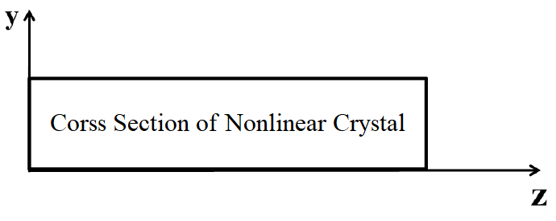

Convection

&

Radiation

Convection

&

Radiation

T = cte

Boundary Condition?